

10 December 2017

Addison Tyres encourages drivers to check tyres before Festive travel

With the Christmas lights on and holiday plans in place, Addison Tyres is urging drivers to check their car’s tyres before they head off on Festive visits.

Staggeringly, research has revealed more than half of all tyres are below the recommended legal limit which is especially dangerous when a car is fully-laden with family, luggage and gifts on board. Checking your tyres air pressure is also very important. Low air pressure in tyres makes a vehicle more difficult to control and reduces the amount of grip with the road, increasing braking distances and the chances of aquaplaning.

While adjusting your tyre pressures Addison Tyres is also advising drivers to check the tyres have enough tread. The legal limit is 1.6mm but if the owner is in any doubt, it should be checked by a tyre technician

For those who don’t feel confident doing that themselves, Addison Tyres is offering a free Christmas tyre check. As an official supporter of TyreSafe, Addison Tyres has been campaigning to raise awareness of the importance of regular tyre checks to minimise the risk of a tyre-related incidents.

Jason Addison Director of Addison Tyres said: “Far too many accidents are caused simply because drivers haven’t checked their tyres before they take to the road. Even if that results in a puncture or other tyre-related breakdown, you can be sure the journey will be nowhere near as pleasant as it might have been. Between them, the breakdown recovery services attend thousands of tyre-related call-outs every year so you can be sure of a wait before help will arrive.

Addison Tyres wants drivers to have a tyre safe and Merry Christmas. All are welcome to visit us and let us help them reduce the risks of an incident on the roads during the holiday season.”

With the recent heavy snowfall it is strongly advised to use Winter tyres or All season tyres for drastically improved grip in cold conditions…

For more information, call Addison Tyres on 01215574019 or visit tyresafe.org for further details on the importance of tyre safety.

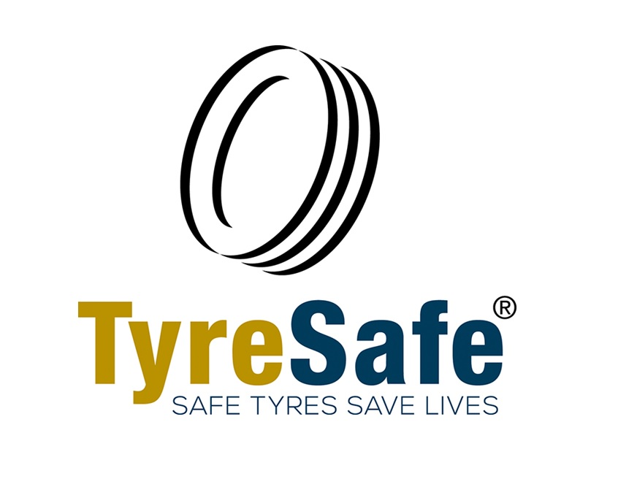 | TyreSafe is the UK’s charity dedicated to raising awareness of the importance of correct tyre maintenance and the dangers of defective and illegal tyres (registration number 1168354)

